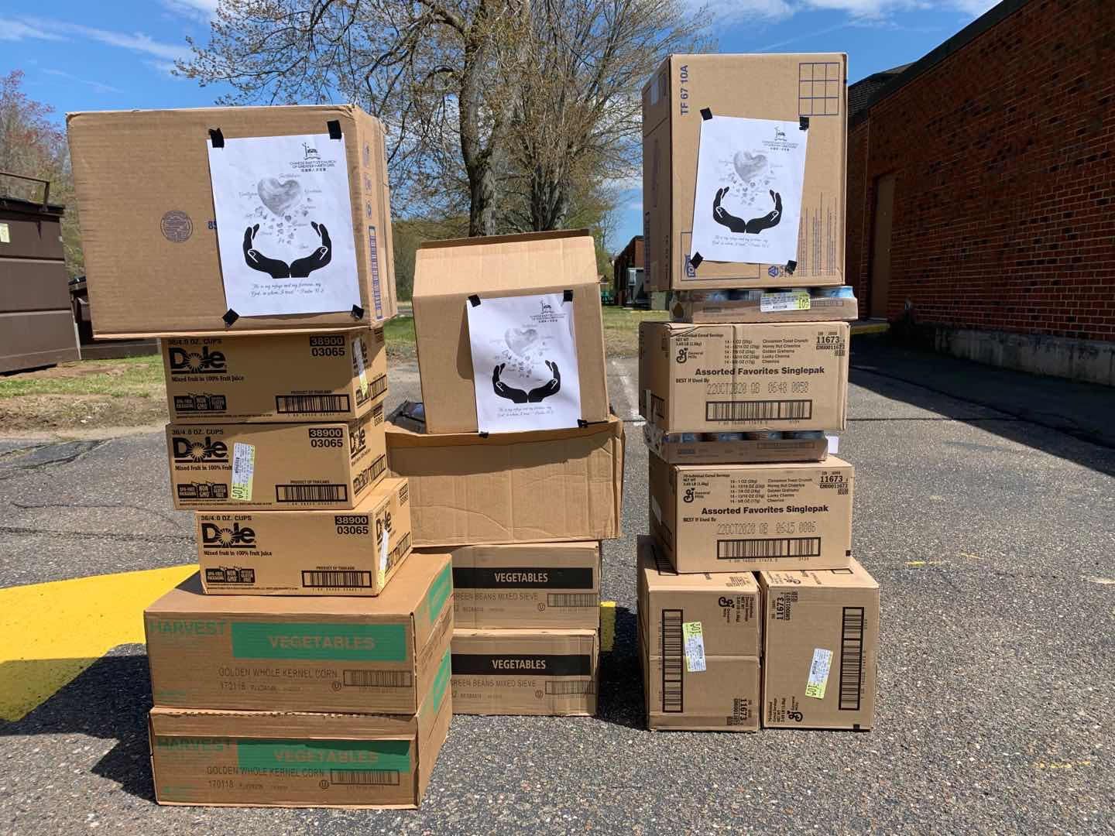

COVID-19救助基金5/17报告：

感谢神的带领，感谢弟兄姐妹在在祷告中，在财务上，和其他爱心的支持。

以下是本周的报告：
- 根据董岩弟兄的统计，到5月14号为止，已经捐款和承诺捐款的金额是$34,490。已经订购的医疗用品的金额大致为$20,000。已经捐赠的食品金额大致为$2,000。
- 订购的的两万个医疗口罩，本周已经全部收到，我们正在联系有需要的老人院等机构，决定捐赠数量。
- 在收到的两万个口罩中，我们将留2000个口罩作为将来CBCGH开放时使用，1000个口罩作为捐赠食物时使用。其余的17,000个口罩将全部捐赠给有需要的老人院等机构。
- 纽黑文新港加略山華人浸信會捐赠我们教会36件防护服，我们将捐给有需要的医院和老人院。
- 本周我们继续和Bloomfield的教会合作foodshare，5/14日我们捐赠了大概$700食物给Wintonbury Church。
- 我们将成立“捐赠食物小组”，从这个星期开始，这个小组将决定，协调，和执行所有的捐赠食物事工。

也请大家继续为这项事工祷告。【箴言 3:5-6】”你要專心仰賴耶和華，不可倚靠自己的聰明， 在你一切所行的事上都要認定他，他必指引你的路。”

COVID-19 救助基金小组

COVID-19 Relief Fund 5/17 report:

We thank God for his leadership. We also want to give thanks to all the brothers and sisters for their prayer, financial support, and other assistance.

Below is this week’s update:
1. As per Brother Yan Dong, as of May 14th, the amount of donated and pledged donations is $ 34,490. As of today, we already ordered $20,000 medical supplies, and donated $2,000 food.
2. By last Friday, we already received all the 20,000 medical masks. We are in the process to reach out nursing homes, and decide donation volume.
3. Within 20,000 masks received, 2000 masks are reserved for CBCGH use in the future, and 1000 masks are reserved for food share activities. The rest of 17,000 masks will be donated to nursing homes, etc.
4. Calvary Chinese Baptist Church of New Haven donated 36 medical gowns to CBCGH, and these medical gowns will be donated to hospital and nursing home.
5. We continue working with other churches in Bloomfield on food share this week and donated $700 food to Wintonbury Church on 5/14.
6. We are going to set up a new team “Food Distribution Team”. Starting from this week, this team will decide, coordinate, and execute all the food share activities.

We ask everyone to continue to pray for all the relief works. [Proverbs 3:5-6] “Trust in the Lord with all thine heart; and lean not unto thine own understanding. In all thy ways acknowledge him, and he shall direct thy paths.”

Best,
Covid-19 Relief Fund Committee

