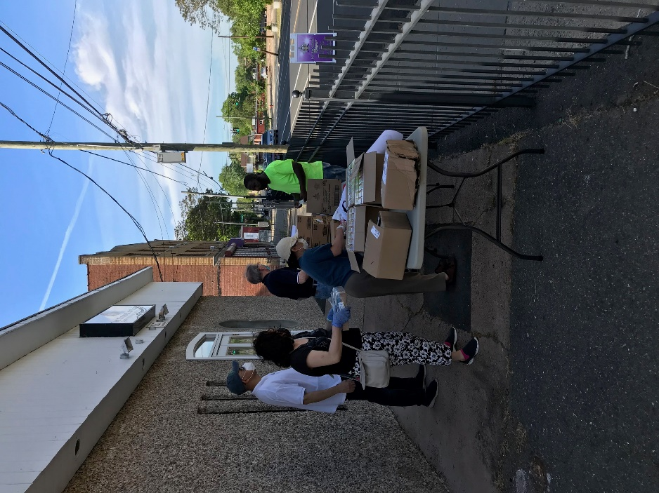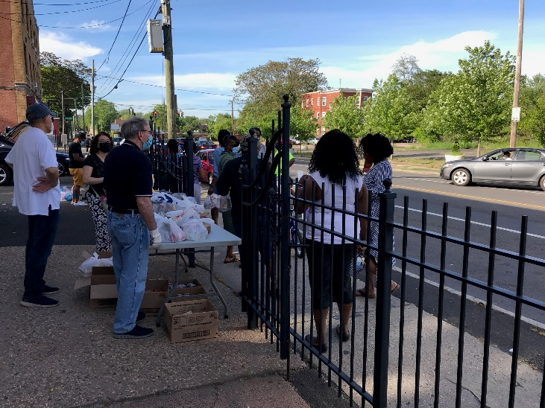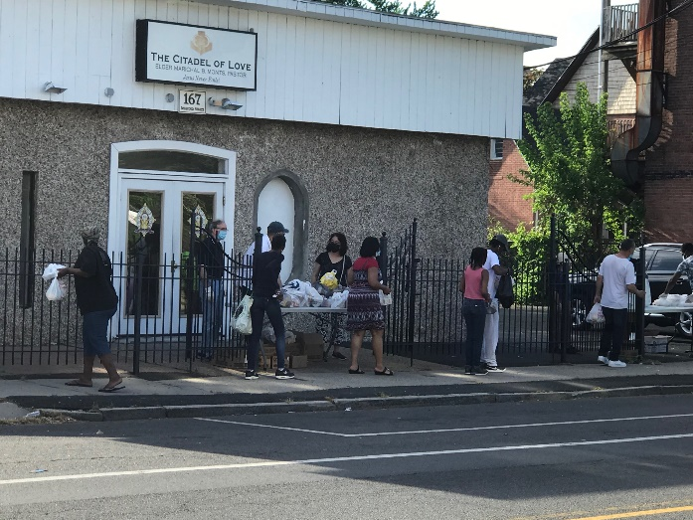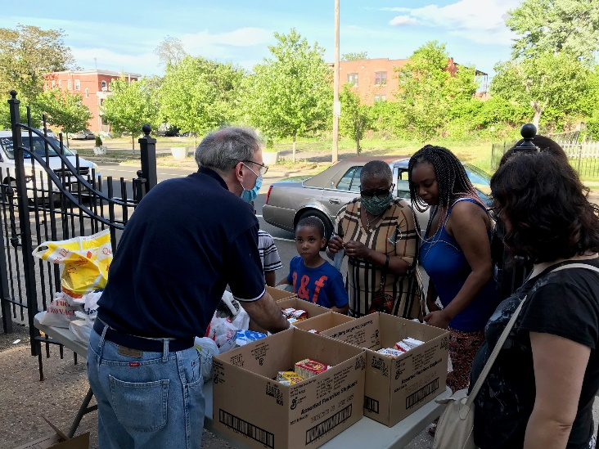

COVID-19救助基金5/31报告：

感谢神的带领，感谢弟兄姐妹在在祷告中，在财务上，和其他爱心的支持。

以下是本周的报告：
- 根据董岩弟兄的统计，到5月24号为止，捐款的金额是$41,665。订购的医疗用品的金额大致为$20,000。购买食品的金额大致为$3,400。
- 订购的的两万个医疗口罩中，剩下的6000个口罩，2000个口罩作为将来CBCGH开放时使用，2000个口罩作为捐赠食物事工时使用，2000个口罩捐赠了给了以下弟兄姐妹工作的餐馆，Sun Sun restaurant (100)， Panda King (100) ，Noble (200) ，Gobi (200) ，Sun Hing (100) ，Peking (100) ，Oishi (100) ，Sakura Garden (200) ，Sakura Garden (200) ，Royal Buffet (200) ，Yume (200) ，Hong Kong (100) ，Sakura Kitchen (100) 。
- 上周三我们第一次参与Hartford地区的教会的捐赠食物事工，购买食品并分发给Citadel Of Love教会附近的有需要的家庭。
- 经过讨论，执事会决定在Covid-19救济基金下成立一个新的小组“捐赠食物小组”，以决定，协调和执行所有捐赠食物的事工。我们邀请有感动的弟兄姐妹加入小组，并参加这些食物捐赠的事工，以帮助我们的社区。愿意参与这项事工的弟兄姐妹，请联系Wendy Lee师母。

也请大家继续为这项事工祷告。【箴言 3:5-6】”你要專心仰賴耶和華，不可倚靠自己的聰明， 在你一切所行的事上都要認定他，他必指引你的路。”

COVID-19 救助基金小组

COVID-19 Relief Fund 5/31 report:

We thank God for his leadership. We also want to give thanks to all the brothers and sisters for their prayer, financial support, and other assistance.

Below is this week’s update:
- As per Brother Yan Dong, as of May 24th, the amount of donated and pledged donations is $ 41,665. As of today, we already ordered $20,000 medical supplies, and donated $3,400 food.
- For the remaining 6,000 medical masks received, 2000 masks are reserved for CBCGH use in the future, 2000 masks are reserved for food share activities, 2000 masks were donated to following restaurants, Sun Sun restaurant (100), Panda King (100) ,Noble (200) , Gobi (200) , Sun Hing (100) , Peking (100),Oishi (100) ,Sakura Garden (200) ,Sakura Garden (200) ,Royal Buffet (200) ,Yume (200) ,Hong Kong (100) ,Sakura Kitchen (100).
- Last Wednesday, first time we joined food share activity with churches in Hartford area to distribute foods to families near the Citadel of Love Church.
- After discussion, Deacon Board decided to set up a new team “Food Distribution Team” under Covid-19 Relief Fund to decide, coordinate, and execute all the food share activities. We invite church members to join the team and participate in these food share activities to support our community. If you want to join this ministry, please contact Wendy Lee.

We ask everyone to continue to pray for all the relief works. [Proverbs 3:5-6] “Trust in the Lord with all thine heart; and lean not unto thine own understanding. In all thy ways acknowledge him, and he shall direct thy paths.”

Best,
Covid-19 Relief Fund Committee

