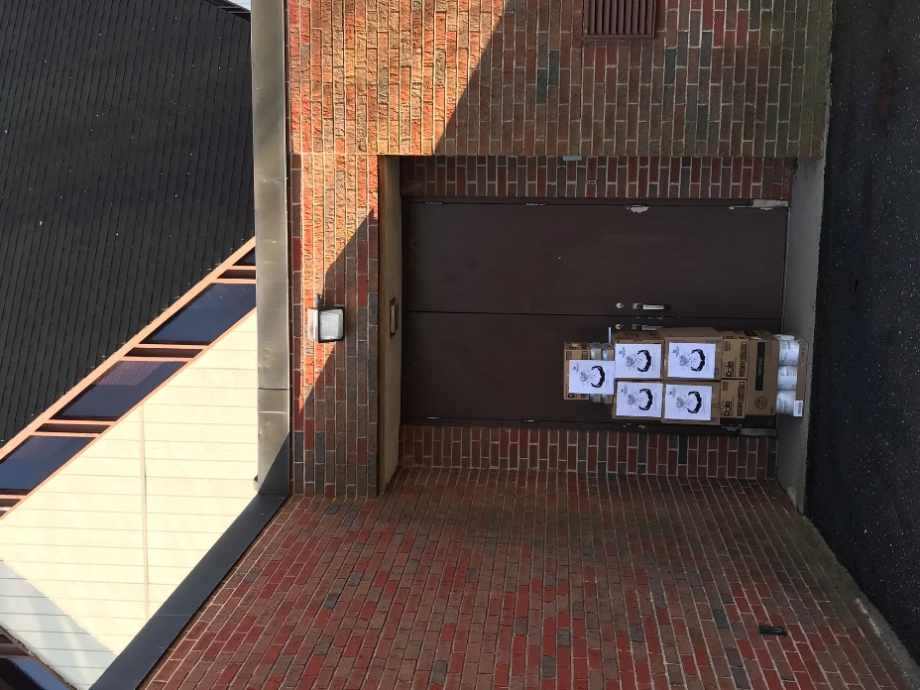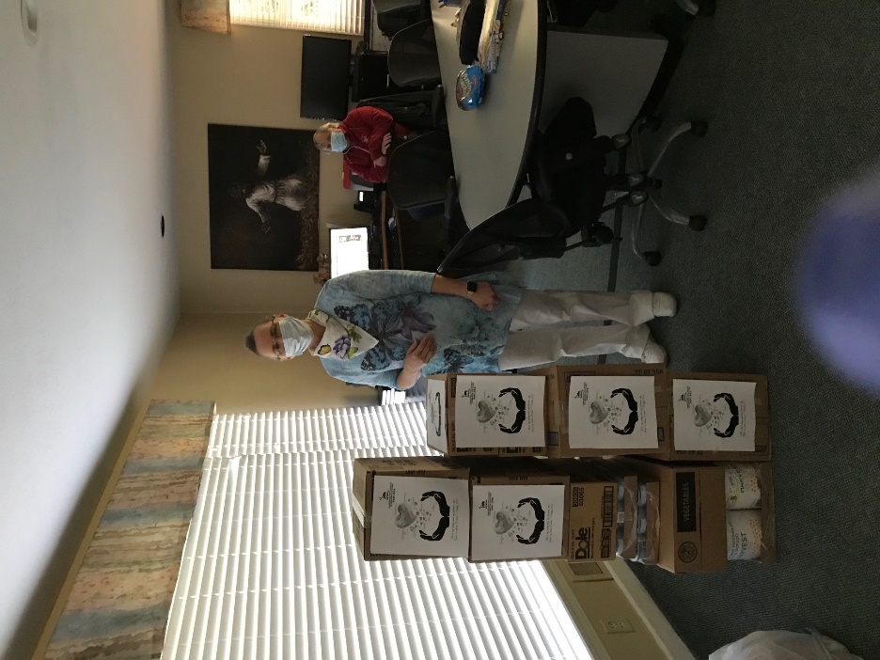

COVID-19救助基金5/9报告：

感谢神的带领，感谢弟兄姐妹在在祷告中，在财务上，和其他爱心的支持。

以下是本周的报告：
- 根据董岩弟兄的统计，到5月7号为止，已经捐款和承诺捐款的金额是$34,490。已经订购的医疗用品的金额大致为$20,000。已经捐赠的食品金额大致为$1,300。
- 已经订购的的两万个医疗口罩，4/27日已经到达美国，正在进口海关程序中。
- 本周我们继续和Bloomfield的其他Church合作foodshare，5/7日我们捐赠了大概$500食物给Bloomfield Senior Center。

也请大家继续为这项事工祷告。【箴言 3:5-6】”你要專心仰賴耶和華，不可倚靠自己的聰明， 在你一切所行的事上都要認定他，他必指引你的路。”

COVID-19 Relief Fund 5/9 report:

We thank God for his leadership. We also want to give thanks to all the brothers and sisters for their prayer, financial support, and other assistance.

Below is this week’s update:
1. As per Brother Yan Dong, as of May 7th, the amount of donated and pledged donations is $ 34,490. As of today, we already ordered $20,000 medical supplies, and donated $1,300 food.
2. The 20,000 medical masks ordered three weeks ago arrived in U.S. on 4/27 and we are waiting for import customs clearance.
3. We continue working with other churches in Bloomfield on food share this week and donated $500 food to Bloomfield Senior Center on 5/7.

We ask everyone to continue to pray for all the relief works. [Proverbs 3:5-6] “Trust in the Lord with all thine heart; and lean not unto thine own understanding. In all thy ways acknowledge him, and he shall direct thy paths.”

Best,
Covid-19 Relief Fund Committee

