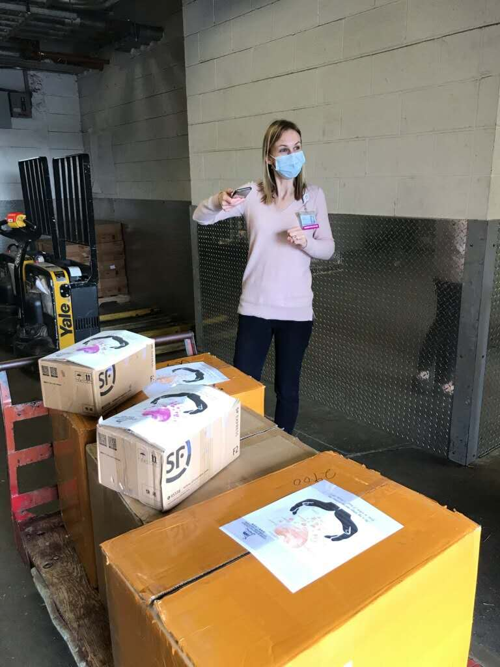

COVID-19救助基金4/26报告：

感谢神的带领，感谢弟兄姐妹在在祷告中，在财务上，和其他爱心的支持。

以下是本周的报告：
- 根据董岩弟兄的统计，到4月23号为止，已经捐款和承诺捐款的金额是$34,490。已经订购的医疗用品的金额大致为$25,000。
- 周五（4月17日）收到的5910个外科口罩，已经和弟兄姐妹捐的400个口罩一起捐给了Hospital of Central Connecticut。
- 已经订购的的两万个医疗口罩，正在运输的过程中。
- 4月23日追加订购一万个医疗口罩，正在订单处理过程中。
- 本周我们准备开始和Bloomfield其他的教会合作， 帮助Bloomfield的一些受疫情影响的家庭，计划捐赠$1000食物给这些家庭。

也请大家继续为这项事工祷告。【箴言 3:5-6】”你要專心仰賴耶和華，不可倚靠自己的聰明， 在你一切所行的事上都要認定他，他必指引你的路。”

COVID-19 Relief Fund 4/26 report:

We thank God for his leadership. We also want to give thanks to all the brothers and sisters for their prayer, financial support, and other assistance.

Below is this week’s update:
1. As per Brother Yan Dong, as of April 23th, the amount of donated and pledged donations is $ 34,490. As of today, we already ordered $25,000 medical supplies.
2. On Friday (April 17th) we received 5,910 surgical masks, and donated to Hospital of Central Connecticut last week with 400 masks from brothers and sisters.
3. The 20,000 medical masks ordered two weeks ago are still en route.
4. We placed another order of 10,000 medical masks on last Wednesday (April 22rd).
5. This week we plan to collaborate with other Bloomfield churches on food share and will donate $ 1000 food to the families affected by Covid-19 in Bloomfield.

We ask everyone to continue to pray for all the relief works. [Proverbs 3:5-6] “Trust in the Lord with all thine heart; and lean not unto thine own understanding. In all thy ways acknowledge him, and he shall direct thy paths.”

Best,
Covid-19 Relief Fund Committee

