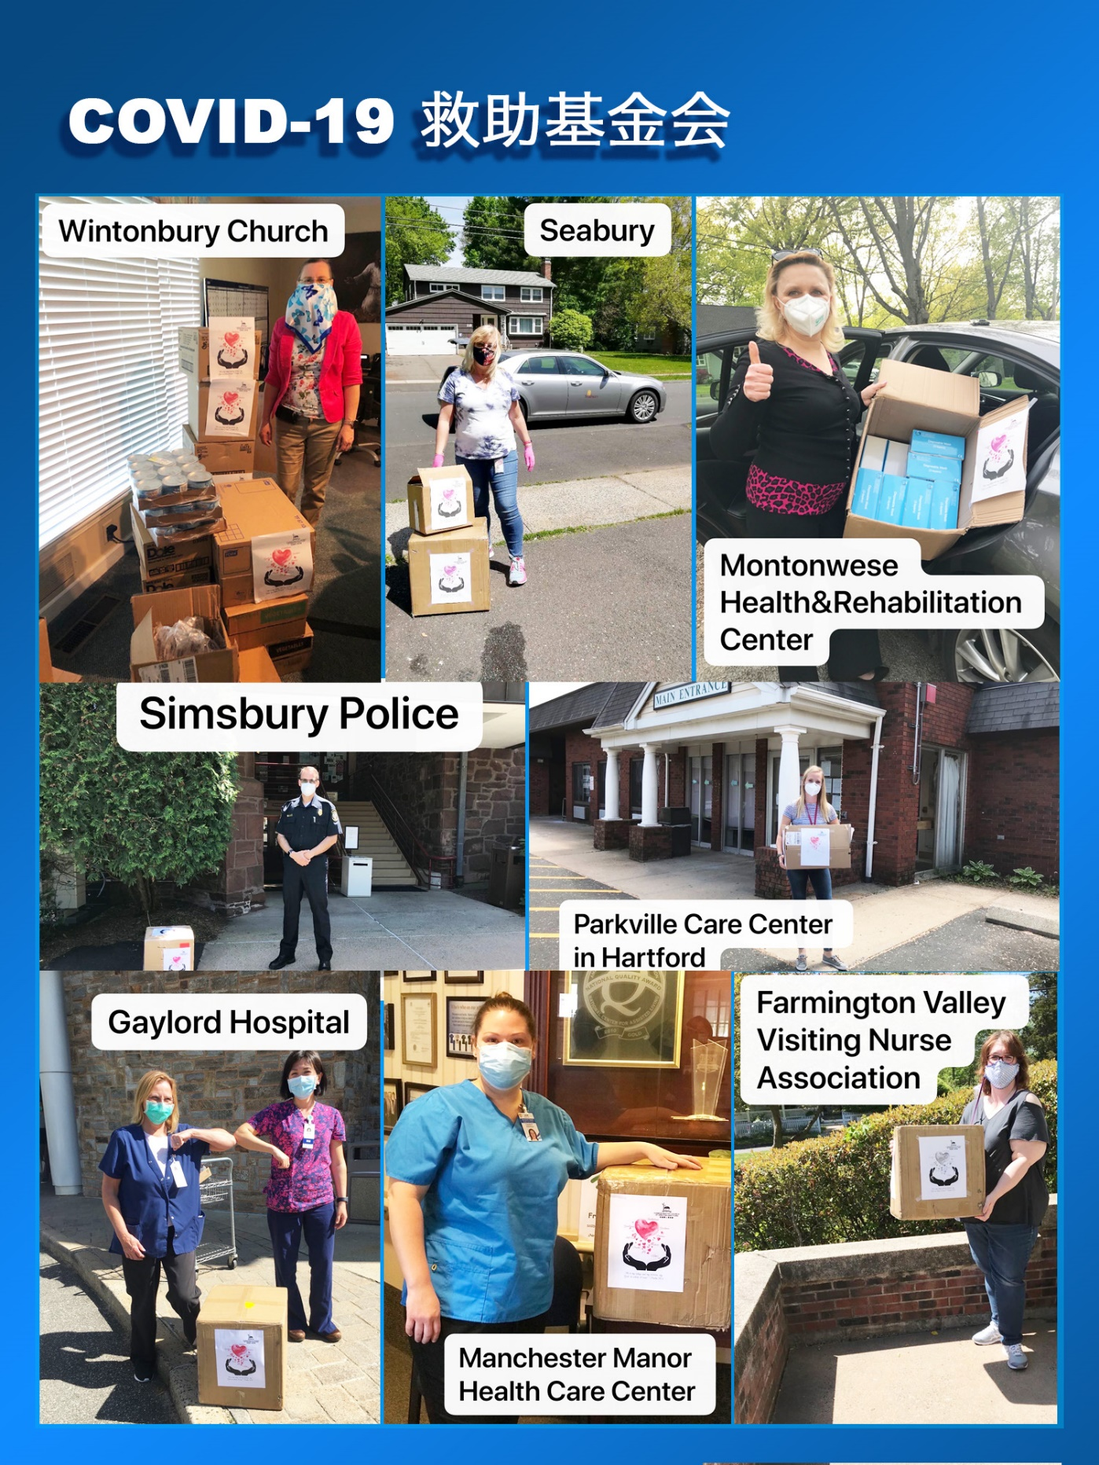

COVID-19救助基金5/24报告：

感谢神的带领，感谢弟兄姐妹在在祷告中，在财务上，和其他爱心的支持。

以下是本周的报告：
- 根据董岩弟兄的统计，到5月17号为止，已经捐款的金额是$41,265。已经订购的医疗用品的金额大致为$20,000。已经捐赠的食品金额大致为$2,700。
- 订购的的两万个医疗口罩，上周已经捐赠了14000个口罩给以下机构，Nursing homes in New Haven （4000），Manchester Manor Health Care Center (2000)，Gaylord Hospital (2000)，Simsbury Police，Simsbury Ambulance, & Simsbury Fire Department（2000），Seabury (2000)，Parkville Care Center in Hartford（1000），Farmington Valley Visiting Nurse Association（1000）。
- 上周我们继续和Bloomfield的教会合作foodshare，5/21日我们捐赠了大概$650食物给Wintonbury Church。本周开始Bloomfield地区的教会停止了接受食物捐赠，接下来我们将支持Hartford地区的教会的捐赠食物事工，购买食品并捐赠给Citadel Of Love教会。
- 经过讨论，执事会决定在Covid-19救济基金下成立一个新的小组“捐赠食物小组”，以决定，协调和执行所有捐赠食物的事工。我们邀请有感动的弟兄姐妹加入小组，并参加这些食物捐赠的事工，以帮助我们的社区。

也请大家继续为这项事工祷告。【箴言 3:5-6】”你要專心仰賴耶和華，不可倚靠自己的聰明， 在你一切所行的事上都要認定他，他必指引你的路。”

COVID-19 救助基金小组

COVID-19 Relief Fund 5/24 report:

We thank God for his leadership. We also want to give thanks to all the brothers and sisters for their prayer, financial support, and other assistance.

Below is this week’s update:
- As per Brother Yan Dong, as of May 17th, the amount of donated and pledged donations is $ 41,265. As of today, we already ordered $20,000 medical supplies, and donated $2,700 food.
- in last week, for the 20,000 medical masks received, we donated 14,000 masks to following institutions, Nursing homes in New Haven (4000),Manchester Manor Health Care Center (2000), Gaylord Hospital (2000), Simsbury Police，Simsbury Ambulance, & Simsbury Fire Department (2000),Seabury (2000),Parkville Care Center in Hartford (1000),Farmington Valley Visiting Nurse Association(1000).
- We continue working with other churches in Bloomfield on food share this week and donated $700 food to Wintonbury Church on 5/21. From this week, Bloomfield churches stopped accepting food donation. We will continue food share ministry and support churches in Hartford area in the future.
- After discussion, Deacon Board decided to set up a new team “Food Distribution Team” under Covid-19 Relief Fund to decide, coordinate, and execute all the food share activities. We invite church members to join the team and participate in these food share activities to support our community.

We ask everyone to continue to pray for all the relief works. [Proverbs 3:5-6] “Trust in the Lord with all thine heart; and lean not unto thine own understanding. In all thy ways acknowledge him, and he shall direct thy paths.”

Best,
Covid-19 Relief Fund Committee

