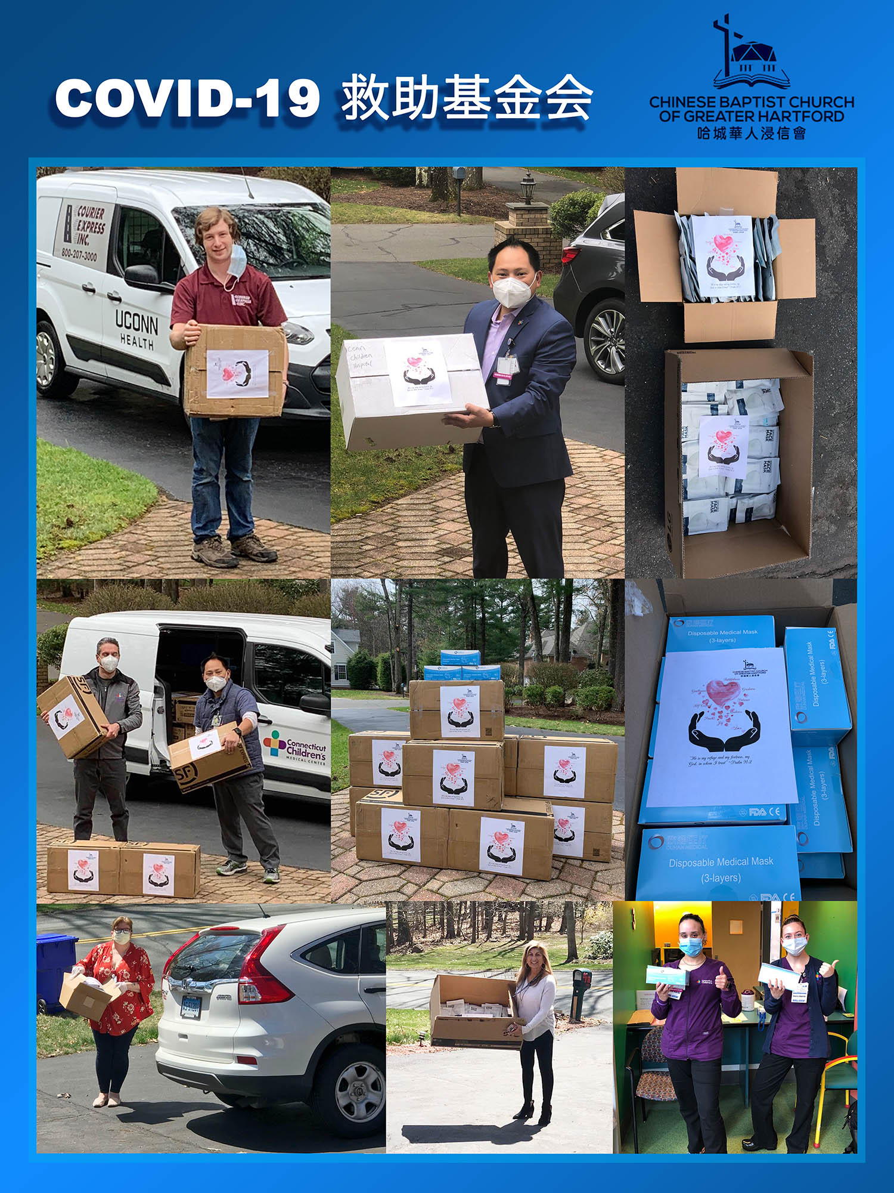

COVID-19救助基金4/12报告：

现在我们居住的每一个城镇都有Covid-19疫情，感染人数每天在不断增加，医治的地方从医院扩大到老人院和康复中心，医护用品的需求也在不断增长。感谢神的带领，感谢弟兄姐妹在在祷告中，在财务上，和其他爱心的支持。当看到医护人员发来的使用捐赠口罩的相片时，当看到老人院在Facebook上分享我们的捐赠口罩时，也激励我们来做好这项事工。我们小组知道自己的能力有限，正如撒迦利亞書4:6 所说，“他对我说: 这是耶和华指示所罗巴伯的。万军之耶和华说：不是倚靠势力，不是倚靠才能，乃是倚靠我的灵方能成事 。”

以下是本周的报告：
- 根据董岩弟兄的统计，到4月9号为止，已经捐款和承诺捐款的金额是$30,940。我们小组已经订购的医疗用品总金额是$20,300。
- 上周一（4月6日）从纽约的中国厂家购买1100个KN95口罩的现货，每个$3，共计$3,300,捐给了Simsbury 的Governor’s House Nursing Home 和Farmington Valley Visiting Nurse Association，Manchester Manor Health Care Center 和Gaylord Hospital。
- 上周二（4月7日）收到中国橄榄山教会捐赠的2000个医疗口罩，捐给了Connecticut Children Hospital, 和UConn Health Center。
- 上周四（4月9日）收到订购的一万个医疗口罩，全部捐给了Connecticut Children Hospital。
- 上周五（4月10日）又订购了一万个医疗口罩（medical mask），每个$0.45，共计$4,500。
- 已经订购的的两万个医疗口罩，正在运输的过程中。
- 以上所有接受捐赠口罩的医院，老人院和康复中心，都已提供捐赠免责声明文件。

疫情每天在变，医护用品的需求也在变化。我们无法预测明天，我们只是谦卑的来到主前，祈求神的带领。请大家继续为中国的出关手续和运输过程中的顺利来祷告。【诗篇127:1】“若不是耶和华建造房屋，建造的人就枉然劳力，若不是耶和华看守城池，看守的人就枉然警醒。”

Covid-19 救助基金小组

COVID-19 Relief Fund 4/12 report:

Every town we are living in now has many Covid-19 cases. The number of infected people is increasing every day. The treatment facilities expand from hospitals to nursing homes and rehabilitation centers. The demand for medical supplies is growing fast as well. We thank God for his leadership. We also want to give thanks to all the brothers and sisters for their prayer, financial support, and other assistance. We are inspired after seeing the photos from Connecticut Children Hospital and Farmington Valley Visiting Nurse Association. The Farmington Valley Visiting Nurse Association shared our donation story on Facebook. We know our capabilities are limited. As Zechariah 4: 6 has said, "Then he answered and spake unto me, saying, this is the word of the LORD unto Zerubbabel, saying, Not by might, nor by power, but by my spirit, saith the LORD of hosts.”

Below is this week’s update:
1. As per Brother Yan Dong, as of April 9th, the amount of donated and pledged donations is $ 30,940. As of last week, total amount of medical supply order is $20,300.
2. On Monday (April 6th), we purchased 1100 KN95 masks from Chinese manufacturer in New York for $ 3 each, totaling $ 3,300, and donated to Governor ’s House Nursing Home, Farmington Valley Visiting Nurse Association, Manchester Manor Health of Simsbury Care Center, and Gaylord Hospital.
3. On Tuesday (April 7th), we received 2,000 medical masks donated by the Mount of Olives Church in China and donated them to the Connecticut Children Hospital, and UConn Health Center.
4. On Thursday (April 9th) we received 10,000 medical masks, and donated all to the Connecticut Children Hospital.
5. On Friday (April 10th) we placed another order of 10,000 medical masks. ($ 0.45 each for a total of $ 4,500).
6. The 20,000 medical masks ordered last week are still en route.
7. All hospitals, nursing homes and rehabilitation centers that received donation masks have provided Waiver of Liability documents.

The epidemic situation changes every day, and the demand for medical supplies is also changing. While we cannot predict tomorrow, we humbly pray for God's leadership and guidance. We ask everyone to continue to pray for the customs clearance procedures and the smooth transportation of these medical supplies. Lastly, we leave you with [Psalm 127: 1] " A Song of degrees for Solomon. Except the LORD build the house, they labour in vain that build it: except the LORD keep the city, the watchman waketh but in vain. "

Best,
Covid-19 Relief Fund Committee

